Telephone/F ax:
+48 81 535 3000
+48 81 535 3005
Asseco Business Solutions
ul. Konrada Wallenroda 4c. 20-607 Lublin, Poland

ASSECO BUSINESS SOLUTIONS

Lublin, 12 September 2017.

1ST SHAREHOLDERS’ NOTICE ABOUT THE INTENT TO MERGE
The Management Board of Asseco Business Solutions S.A., having its registered office in Lublin (“the Company”), acting pursuant to Article 504 of the Act of 15 September 2000 – the Code of Commercial Companies and Partnerships (“CCCP”), hereby notifies its shareholders – for the first time – of its intention to merge with Macrologic Spółka Akcyjna, having its registered office in Warsaw, pursuant to the terms specified in the Merger Plan made public on 12 September 2017 on the website: www.assocobs.pl and made available until the end of the General Meeting adopting a resolution on the Merger. At the same time, the Management Board of Asseco Business Solutions S.A. informs that the Company, as set out in Article 505 § 3¹ CCCP, and no later than one month before the date of the General Meeting that shall adopt a resolution on the Merger, and on a continuous basis until the end of the meeting adopting the resolution on the Merger, shall make public on its website www.assocobs.pl in the tab: About Us: Pressroom: News, the following documents under Article 505 § 1 CCCP:
- Merger Plan;
- financial reports and reports of the Management Boards on the activities of the merging companies for the operation over three preceding financial years, together with the opinion and report of a certified auditor;
- draft resolutions of the General Meetings concerning the Merger;
- determination of the assets of the Target Company – Macrologic – as at 31 August 2017;
- a statement containing information on the accounting situation of the Target Company – Macrologic – drawn up for the Merger purposes as at 31 August 2017.
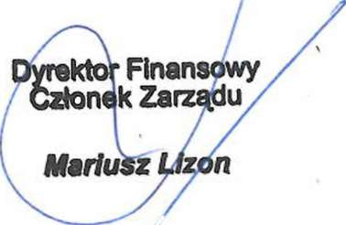

This announcement was also made public by the Company in Current Report No. 34/2017 .

President of the Management Board

Wojciech Barczentewicz

Asseco Business Solutions S.A., having its registered office in Lublin, at ul. Konrada Wallenroda 4c, 20-607.
District Court for Lublin-East in Lublin, seated in Świdnik VI Commercial Department of the National Court Register, KRS 0000028257, NIP 522-26-12-717, REGON 017293003; share capital: PLN 167,090,965 (fully paid up).

