ASSECO BUSINESS SOLUTIONS
Draft Resolutions
of the Extraordinary General Meeting of Asseco Business Solutions S.A. seated in Lublin
convened on 26 October 2017
RESOLUTION No. 1 OF THE EXTRAORDINARY GENERAL MEETING OF ASSECO BUSINESS SOLUTIONS S.A. SEATED IN LUBLIN
dated 26 October 2017 concerning the election of Chairperson of the Extraordinary General Meeting
Section 1
The Extraordinary General Meeting of Asseco Business Solutions S.A., acting pursuant to Article 409(1) of the Commercial Companies Code, hereby resolve to elect Mr/Ms.......................... Chairperson of the Extraordinary General Meeting of the Company.
Section 2
The resolution comes into force upon its adoption.
RESOLUTION No. 2 OF THE EXTRAORDINARY GENERAL MEETING OF ASSECO BUSINESS SOLUTIONS S.A. SEATED IN LUBLIN
dated 26 October 2017 concerning: the appointment of the Returning Committee
Section 1
The Extraordinary General Meeting of Asseco Business Solutions S.A. in Lublin appoints the Returning Committee composed of:
- - Committee Member,
- - Committee Member,
- - Committee Member.
Section 2
The resolution comes into force upon its adoption.
RESOLUTION No. 3 OF THE EXTRAORDINARY GENERAL MEETING OF ASSECO BUSINESS SOLUTIONS S.A. SEATED IN LUBLIN
dated 26 October 2017 concerning: the adoption of the agenda
Section 1
The Extraordinary General Meeting of Asseco Business Solutions S.A. in Lublin adopts the following agenda:
- The opening of the General Meeting;
- Election of the Chairperson of the General Meeting;
- Ascertainment of the correctness of convening the General Meeting and its capacity to adopt resolutions;

ASSECO BUSINESS SOLUTIONS
- Appointment of the Returning Committee;
- Adoption of the agenda;
- Adoption of the Resolution concerning the Merger of Asseco Business Solutions S.A. with Macrologic S.A.
- The closing of the General Meeting.
Section 2
The resolution comes into force upon its adoption.

RESOLUTION No. 4 OF THE EXTRAORDINARY GENERAL MEETING OF ASSECO BUSINESS SOLUTIONS S.A. SEATED IN LUBLIN
of 26 October 2017 concerning: the Merger of Asseco Business Solutions S.A. with Macrologic S.A.
Section 1
Acting pursuant to Article 506 of the Act of 15 September 2000 – the Code of Commercial Companies (“CCC”) in conjunction with Article 492 § 1 CCC, Article 515 § 1 CCC and Article 516 § 5 CCC, the Extraordinary General Meeting of Asseco Business Solutions S.A., having its registered office in Lublin, (“the Acquiring Company” as set out in the Merger Plan of 12 September 2017) resolve:
  - to merge with Macrologic Spółka Akcyjna, having its registered office in Warsaw at ul. Księdza Ignacego Kłopotowskiego 22, 03-717 Warszawa, registered in the Companies’ Register at District Court for the Capital City of Warsaw, XIII Economic Department of the National Court Register, under KRS no.: 0000045462, tax ID NIP: 5220002825 and business ID REGON 012205939, with the share capital of PLN 1,888,719.00 divided into 1,888,719 ordinary bearer shares with a nominal value of PLN 1.00 each (the Target Company) by transferring all assets of the Target Company to the Acquiring Company without increasing the share capital of the Acquiring Company, i.e. to merge as provided for in Article 492 § 1(1) CCC and Article 515 § 1 CCC and Article 516 § 5 CCC; as a result of the merger, the Target Company shall be dissolved without liquidation (Article 493 § 1 CCC),
  - to approve the Merger Plan of Asseco Business Solutions S.A., having its registered office in Lublin (as the Acquiring Company) and Macrologic S.A., having its registered office in Warsaw (as the Target Company) agreed between the merging companies in writing on 12 September 2017 and published on the websites of these Companies pursuant to Article 500 §2¹ CCC dated ............... (“the Merger Plan”), in particular, approve:
    - no increase in the share capital in the Acquiring Company,
    - no amendments to the Articles of Association of the Acquiring Company.
Section 2
The Management Board shall be authorized to take all action necessary to implement this Resolution.

Section 3

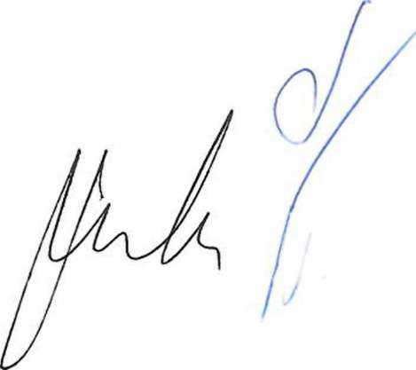
This resolution comes into force upon its adoption.

